1. **Write a Python program to check if the given number is a Disarium Number?**

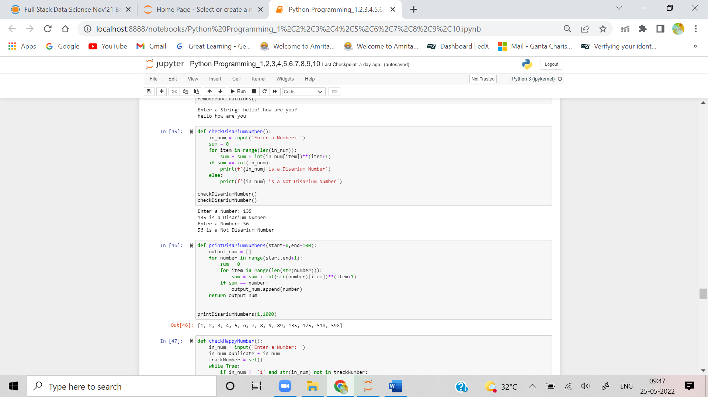

1. **Write a Python program to print all disarium numbers between 1 to 100?**



1. **Write a Python program to check if the given number is Happy Number?**

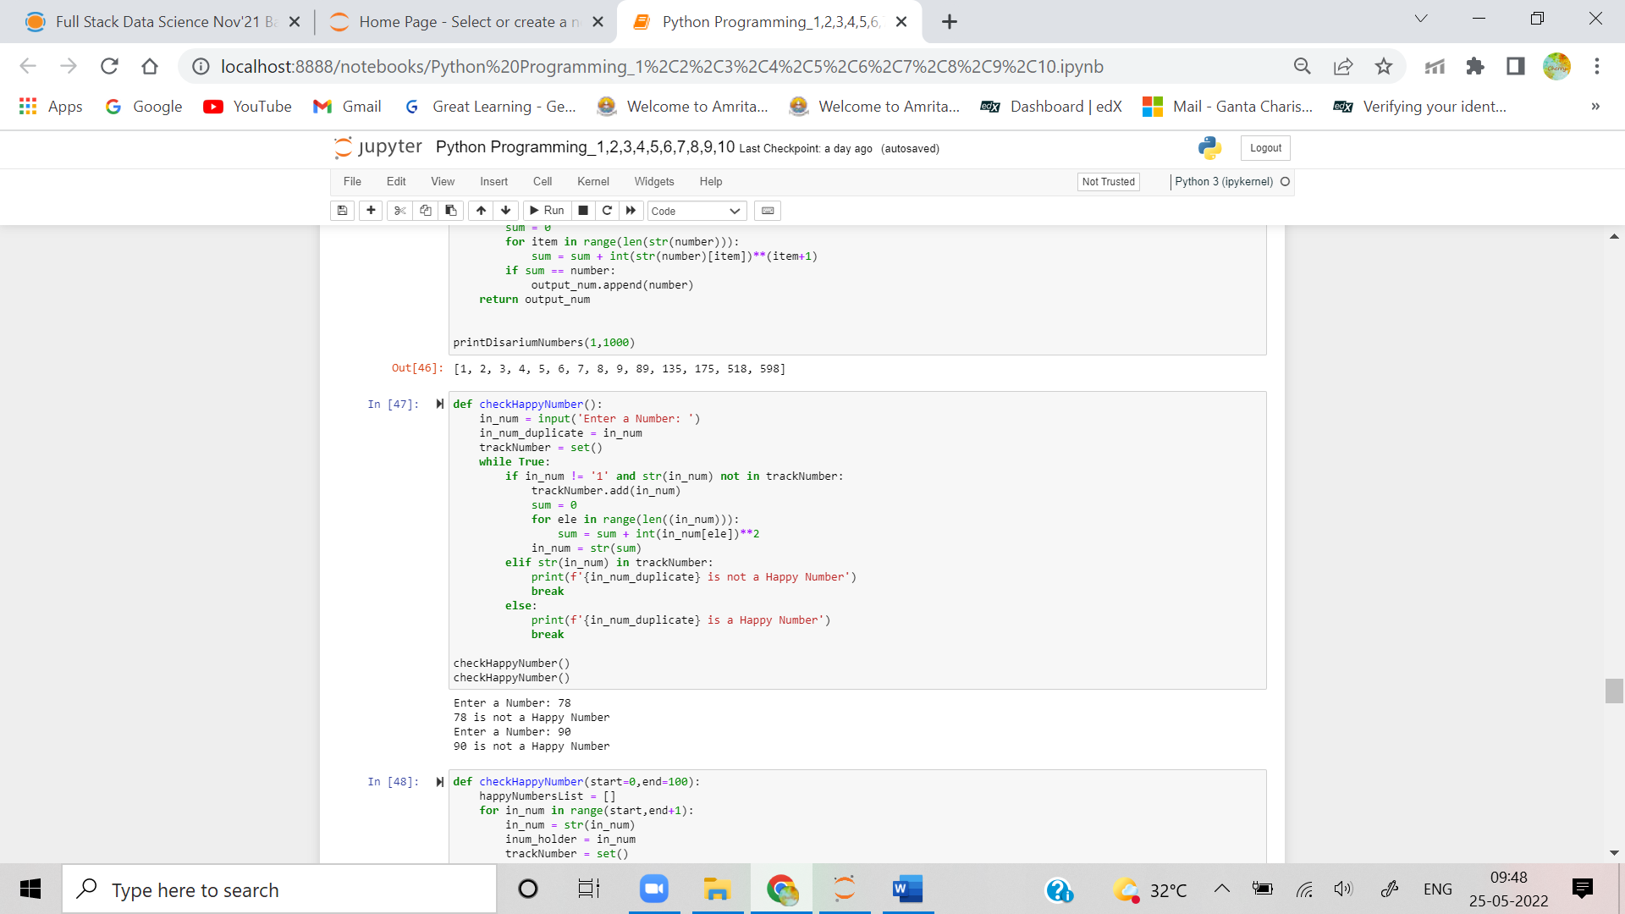

1. **Write a Python program to print all happy numbers between 1 and 100?**

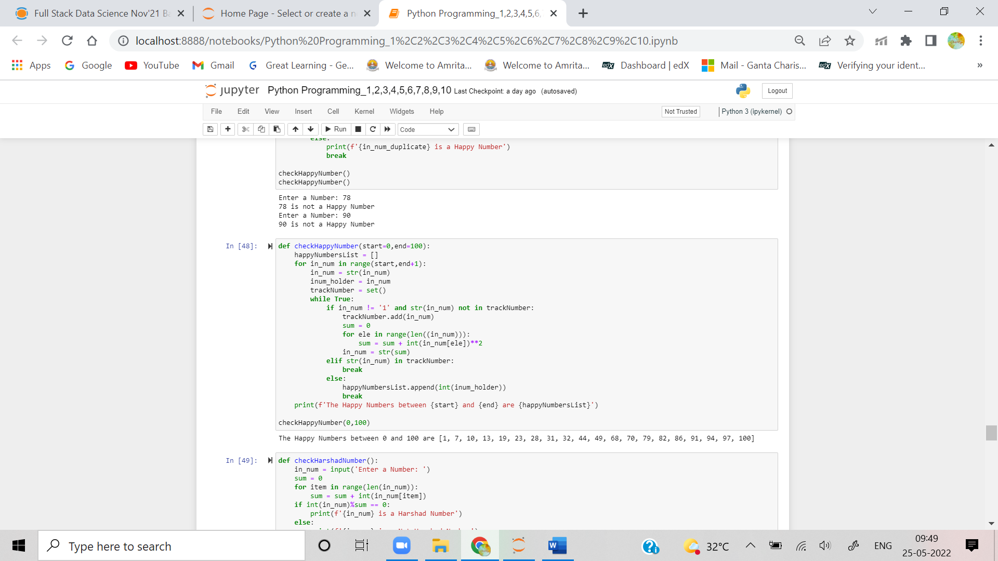

1. **Write a Python program to determine whether the given number is a Harshad Number?**

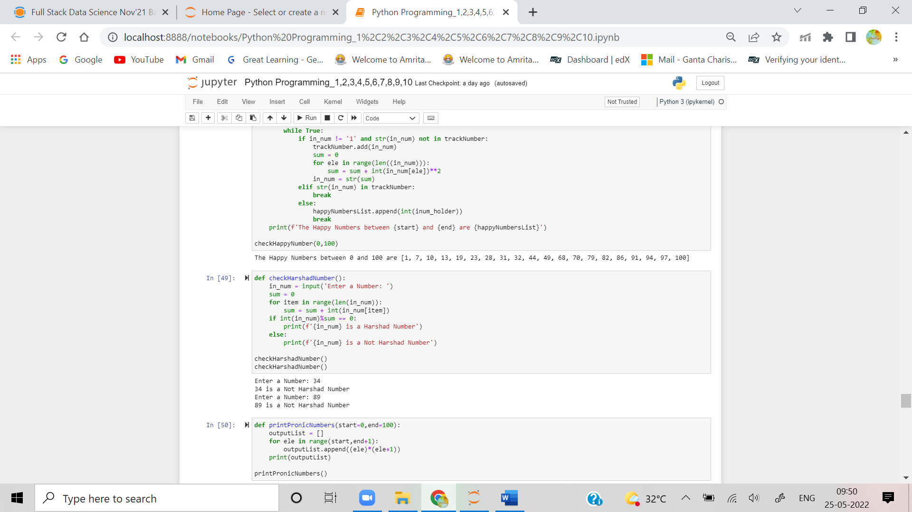

1. **Write a Python program to print all pronic numbers between 1 and 100?**

